**SVKM’s NMIMS**

**Mukesh Patel School of Technology Management and Engineering, Mumbai**

**Department of Electronics & Telecommunication**



**Programming for Problem Solving (Exp 1-2)**

|  |  |
| --- | --- |
| **Roll No: J001** | **Name: Adith Ramakrishna** |
| **Program: B. Tech Data Science (1st)** | **Batch: J1** |
| **Date of Experiment: 03/10/2022** | **Date of Submission: 03/10/2022** |

**Task 1:**

**Flowchart:**

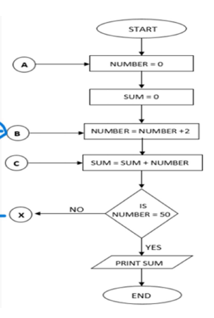

**Task 2:**

**1.**

**Algorithm:**

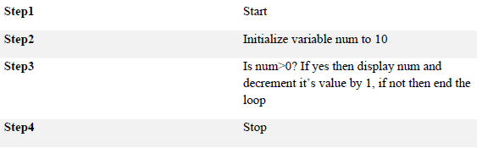

**Flowchart:**

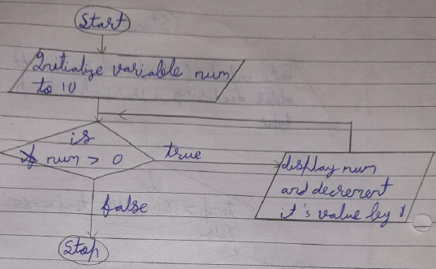

**2.**

**Algorithm:**

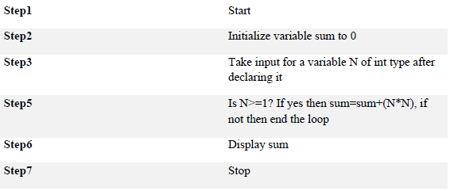

**Flowchart:**

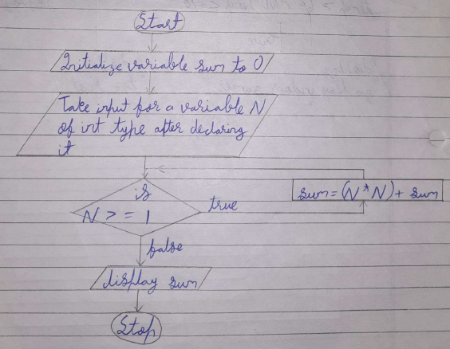

**3.**

**Algorithm:**

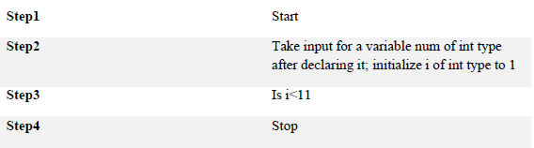

**Flowchart:**

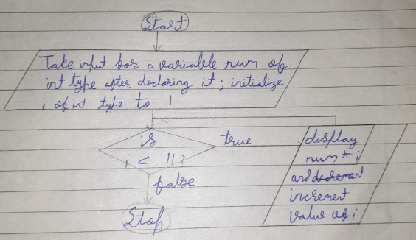

**4.**

**Algorithm:**

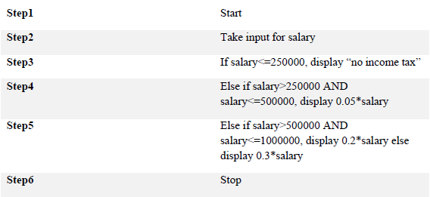

**Flowchart:**



**Homework Questions:**

**1.**

**Algorithm:**

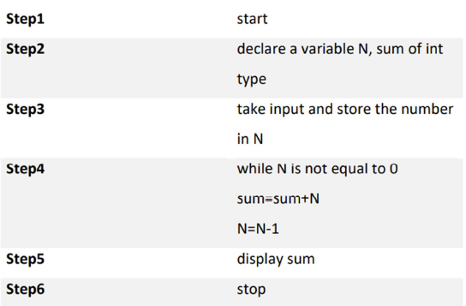

**Flowchart:**

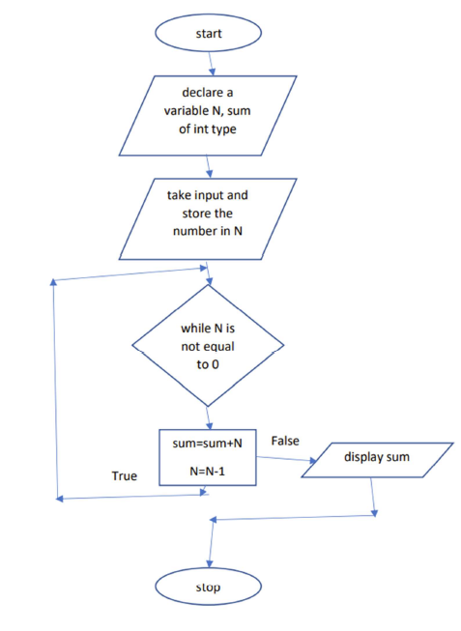

**2.**

**Algorithm:**

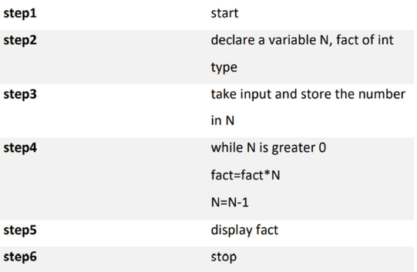

**Flowchart:**

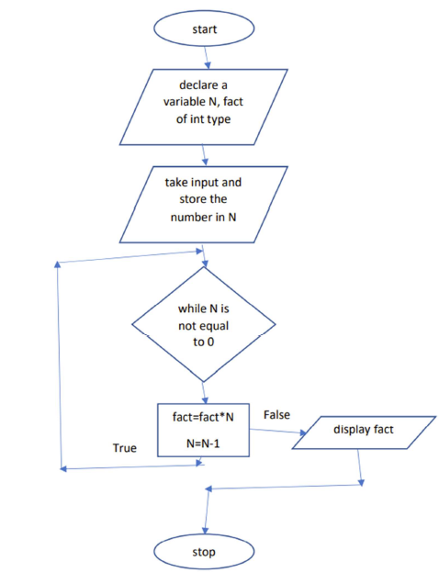

**3.**

**Algorithm:**

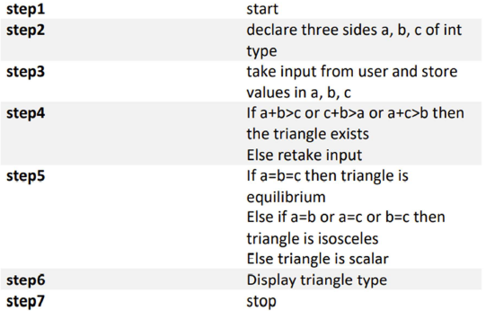

**Flowchart:**

